WHAT IS NUCLEAR POWER?
Nuclear power is an alternative power source that uses the nuclear fission of uranium to create heat and, thereby, through a heat transfer mechanism and turbines, create electricity.
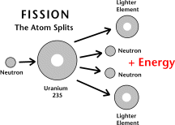
HOW DOES IT WORK?
For a nuclear reactor to create energy it is necessary for nuclear fission to take place. Fission is when an atom is split into smaller particles and an enormous amount of energy is released in the process. The element Uranium is used as the fuel for the reaction because it is radioactive, so it is unstable enough to be broken down into smaller parts. The uranium atom absorbs a neutron and splits into two equal parts and energy is created. This kinetic energy becomes heat energy, which is used to produce electricity.
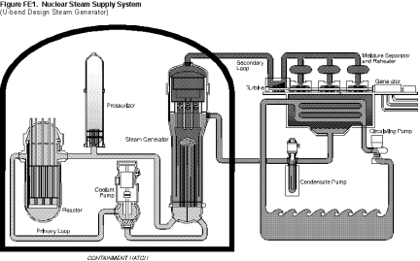
APPLICATIONS OF NUCLEAR POWER
About 440 nuclear reactors are used around the world to produce about 17% of the world's electricity but in theory nuclear fission can be used for much more. At the end of the Second World War the Allies secured victory by dropping the atomic bomb on Japan. The bomb uses the same principles of splitting the atom as the nuclear reactors do in creating electricity. On a smaller, less destructive scale, the theories of nuclear fission are used daily in medicine. Scanning devices and the treatment of cancer both use the radiation from splitting an atom.
ADVANTAGES
- As an alternative to normal coal-based electricity production nuclear power is favorable as it is much more efficient than coal (250g of uranium produces 20000 times more electricity than 250g of coal) and is far less polluting, especially to our atmosphere, as no harmful greenhouse gases are emitted. (ie. carbon monoxide, sulphur dioxide, nitrogen oxide etc.).
- It is generally a reliable process that can be counted on to produce electricity for many years (average availability over three years is about 80%).
- The amount of waste produced each year would cover only your dining room table!
- The waste is stored in fire-, water-, and earthquake-proof capsules to ensure safety.
DISADVANTAGES
- There is pollution in the form of radioactive waste but with new technologies the process is becoming cleaner and safer each year.
- The possibility of radiation leakage or plant meltdown. This is possible in theory and has happened in the past (Chernobyl in Russia) but nowadays there are procedures in place to ensure safety.
- There are problems and dangers, which could lead to accidents. The power stations are all manually run and human error could lead to possible accidents.
- The reactors also have a very expensive capital outlay in the beginning, although the costs are cheaper in the long run.
- The plants do require downtime for maintenance.

